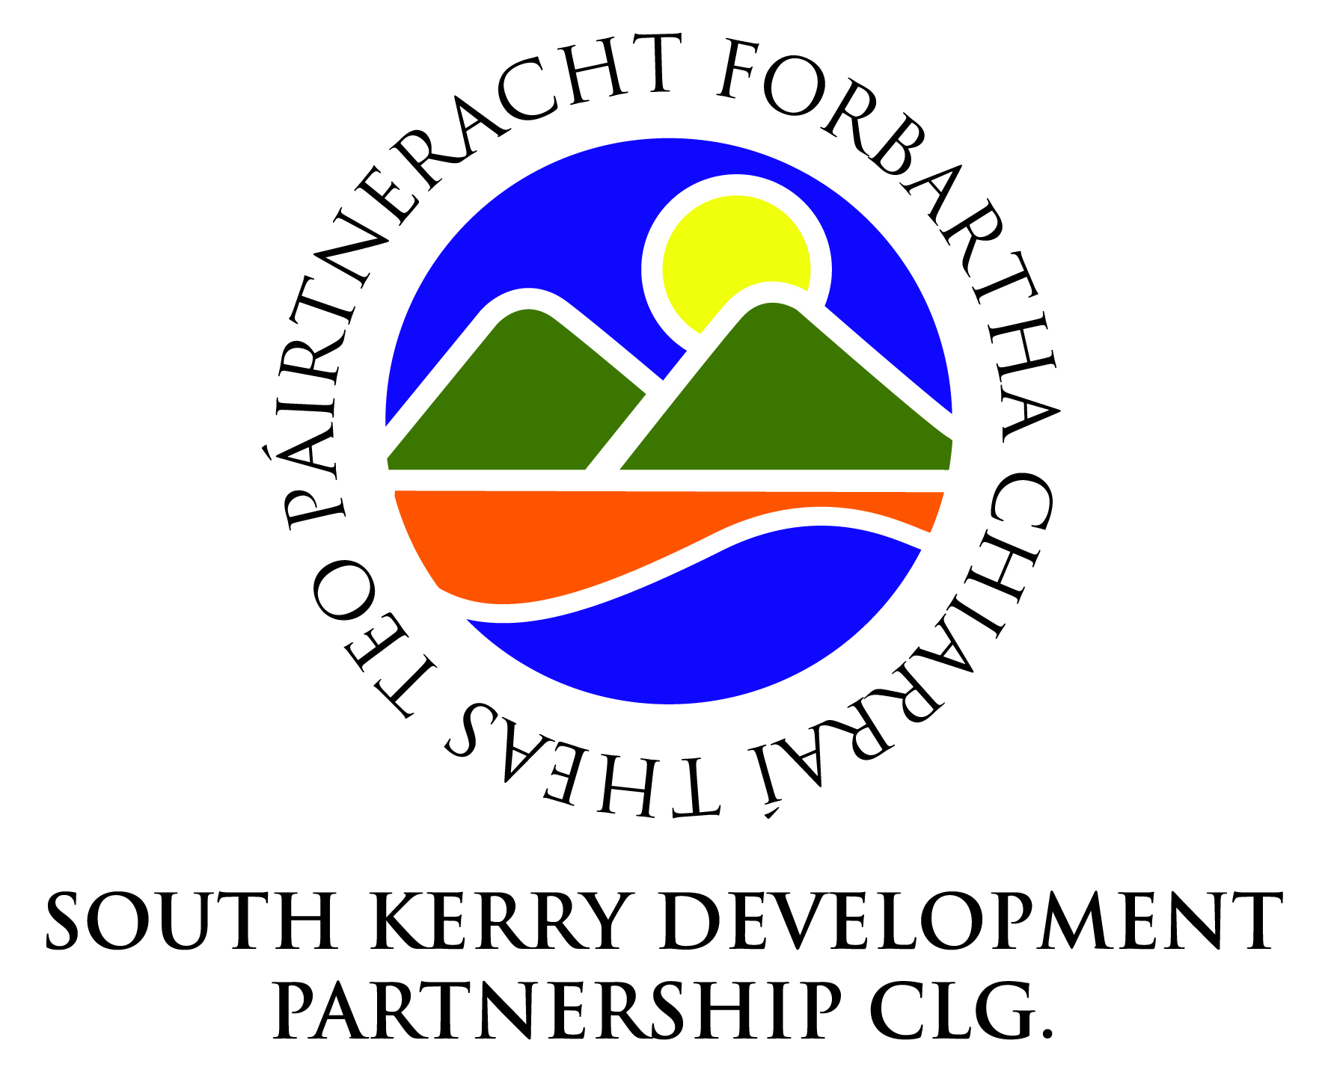
Invites Community Organisations
SKDP invites Community Organisations in its geographic area of coverage to express an interest in a new round of funding under the Community Services Programme (CSP). The CSP is operated by the Department of Social Protection (DSP) to support legally incorporated community organisations to provide local social, economic and environmental services through the application of a social enterprise model of delivery.
This programme may suit if your organisation is:
- A company limited by Guarantee or a Co-operative
- Able to show clear evidence that a service meets a community need and are providing employment opportunities for those most distant from the labour market
- Generating trading income as a social enterprise with at least one set of audited accounts (or in the case of Social Enterprises that do not have audited financial statements due to only recently commencing trading, an income and expenditure account signed by the Chair and Treasurer of the company, and trial balance sheet, for last year can be submitted)
Following an assessment process of the EOIs submitted, SKDP will nominate one applicant organisation to Pobal, to be considered for CSP funding. As the additional funding by Pobal for this targeted call is limited, it will not be possible for all applicant organisations to progress on to CSP funding at this stage. Once all EOIs are received by Pobal they will be assessed and the successful social enterprises will be invited to work with Pobal, who deliver the Programme on behalf of the Department, to establish their suitability for CSP.
To apply for consideration an Expression of Interest Form (EOI) must be submitted in hard copy format to Mr. Noel Spillane, CEO. South Kerry Development Partnership CLG, West Main Street, Cahersiveen, Co Kerry. by 5pm Monday 26th June 2017.
Further information is available on the SKDP website www.southkerry.ie including
- CSP Guidance Document
- Dept. of Social Protection Press Release
- Expression of Interest Form
For any further queries please contact Noel Spillane at nspillane@skdp.net or 0669472724.
