## Rural Development Programme 2014 – 2022 (LEADER)

**Expression of Interest (EOI) Form**

|  |
| --- |
| **NOTE:** This Expression of Interest form **must be completed** as a pre-cursor to an application proper for funding under the Rural Development Programme (RDP) 2014 – 2022 (LEADER).  Failure to complete this form completely will result in a delay in dealing with your Expression of Interest and any further processing of any subsequent application arising therefrom.  **Completion Guidance Notes:**   * Please complete this form in full. All fields are mandatory. * This form can be downloaded or printed from the South Kerry Development Partnership website at [www.southkerry.ie](http://www.southkerry.ie) and forwarded to your local South Kerry Development Partnership office. * Please note the form must be signed and dated. A completed hard copy of the form can be posted or delivered to SKDP at any of its Offices or a signed scanned copy can be emailed to the relevant LEADER Programme Development officer (Details Below) * A hardcopy of this form can be obtained from any of the South Kerry Development Partnership Offices in Cahersiveen, Killorglin, Kenmare or Killarney. * A Rural Development Officer from SKDP will contact you when your **Expression of Interest Form** has been reviewed. * If you require assistance in completing this form please contact the Rural Development Officer in your local area (contact details below).   **For further information on the Leader programme please visit**  [**http://drcd.gov.ie/about/rural/rural-development/leader/**](http://drcd.gov.ie/about/rural/rural-development/leader/) |

|  |  |  |
| --- | --- | --- |
| **Cahersiveen area:**  Maureen O’Donnell  RDP Co-Ordinator - SKDP  West Main Street,  Cahersiveen  066 – 9472724  [modonnell@skdp.net](mailto:modonnell@skdp.net) | **Killorglin / Killarney area:**  Sean de Buitlear,  RDP Officer - SKDP  Library Place,  Killorglin  066 – 9761615  [sdebuitlear@skdp.net](mailto:sdebuitlear@skdp.net) | **Kenmare / Killarney area:**  Aisling O’ Sullivan Darcy  RDP Officer - SKDP  21 Henry Street (1st Floor),  Kenmare  064 – 6641930  [aosullivandarcy@skdp.net](mailto:aosullivandarcy@skdp.net) |

|  |
| --- |
| **IMPORTANT**  **If you haven’t received an acknowledgement of your Expression of Interest Form within 10 working days from date of submission, please contact us.**  Z:\Central Filing System\Departmental Folders\Ent & Emp - EE\RDP 2014 - 2020\Originals\Logos\govt_2040_lockup_colour.png C:\Users\modonnell\AppData\Local\Microsoft\Windows\INetCache\Content.Outlook\9S7BVMVZ\Our Rural Future_Std_Colour.png LEADER logo eafrd-logo-6 **Kerry County Council**  **Funded by the Department of Rural & Community Development** |

|  |  |
| --- | --- |
| **Rural Development Programme (LEADER) 2014 – 2022**  **Expression of Interest (EOI) Form**  **GENERAL INFORMATION**  **All Fields are mandatory and must be completed.** | |
| **Your Local Action Group (LAG) name:** |  |
| **Project Name / Title:** |  |
| **Promoter’s / Community Groups Name:** |  |
| **Promoters Lead / Main Contact Name:** |  |
| **Promoters Main Telephone No.: Promoters E-mail Address:** |  |
| **Promoters E-mail Address:** |  |
| **Promoter’s Address:**  **Please include Eircode** |  |
| **Promoter Type:**  [Individual, Community Group, Organisation, Other]. | **Classification of Promoter:**  *Cross appropriate box.*  Sole Trader  Community Council  Farmer *(If yes Herd No. is required below)*  Trust  Formalised Community/Voluntary group  Partnership  Companies Limited by Guarantee  Company Limited  Designated Activity Company limited by Shares  by shares  Body  Registered Charity  Private Individual  Cooperative society registered under  the Industrial & Provident Societies Act  Other \_\_\_\_\_\_\_\_\_\_\_\_\_\_\_\_\_\_\_\_\_\_\_\_\_\_\_\_\_\_\_\_ |
| **Has Promoter / Community Group received LEADER funding previously?**  **Please Tick one** | Yes  No |
| **PROJECT INFORMATION** | |
| **Project Address:** |  |
| **Project Located in Gaeltacht area:** | Yes  No |
| **Project located on Islands area:** | Yes  No |
| **Estimated Project Costs:**  [Total estimated costs] |  |
| **LEADER funding Required for project:** |  |
| **Project’s Other Funding sources**  *(If any – Bank Loans etc.)* |  |
| **Herd Number:** |  |
| **Please give a brief description of the proposed project.**  [Please use additional sheet and attach to this form if required.] | |

***For Office Use Only:***

**Signed for and on behalf of the Promoter / Group:**

I/ We confirm that the details supplied are true and correct to the best of my/our knowledge

Print Name: \_\_\_\_\_\_\_\_\_\_\_\_\_\_\_\_\_\_\_\_\_\_\_\_\_\_\_\_\_\_\_\_

Signature: \_\_\_\_\_\_\_\_\_\_\_\_\_\_\_\_\_\_\_\_\_\_\_\_\_\_\_\_\_\_\_\_\_\_\_\_

Name in Block Capitals:\_\_\_\_\_\_\_\_\_\_\_\_\_\_\_\_\_\_\_\_\_\_\_\_\_

Date: \_\_\_\_\_\_\_\_\_\_/\_\_\_\_\_\_\_\_\_\_\_\_\_\_\_\_\_\_/\_\_\_\_\_\_\_\_\_

Part or all of the information you provide will be held on computer and hard copy format. This information will be used for the administration of Expression of Interests and producing monitoring returns. LAG’s may share information with each other and government departments/agencies to enable them to prevent fraudulent applications or for detecting crime and to co-ordinate processing of complementary applications.

This policy does not affect your rights and your information will be held as prescribed under the Data Protection Acts.

The promoter/group, the DRCD, Implementing Partner/Animating Partner/LAG Name are subject to the data protection and privacy laws of Ireland and the EU, in particular the Data Protection Act 2018 and Regulation (EU) 2016/679, known as the EU General Data Protection Regulation (“GDPR”). Any personal information that you provide as part of the application process will be obtained and processed in compliance with Data Protection legislation.

This EOI may also be subject to meeting obligations under the Freedom of Information Act 2014. The DRCD, South Kerry Development Partnership, Kerry Local Action Group retain the right to disclose for the purposes of a request under the Freedom of Information Act 2014 or otherwise, in connection with this EOI.

i.  any information supplied by the promoter/group to the DRCD, South Kerry Development Partnership, Kerry Local Action Group;

ii. any relevant data gathered by the DRCD, South Kerry Development Partnership, Kerry Local Action Group in processing this EOI, except where the information is considered to be personal or commercially sensitive.

**EOI Ref ID: \_\_\_\_\_\_\_\_\_\_\_\_\_\_\_\_\_\_\_\_\_\_\_\_\_\_\_\_\_** (Generated from RDP IT System)

**Call Type:** (Rolling / Time Limited) **\_\_\_\_\_\_\_\_\_\_\_\_\_\_\_\_\_\_\_\_\_\_\_\_\_\_\_\_\_\_\_\_.**

**Main Programme Theme:**

**\_\_\_\_\_\_\_\_\_\_\_\_\_\_\_\_\_\_\_\_\_\_\_\_\_\_\_\_\_\_\_\_\_\_\_\_\_\_\_\_\_\_\_\_\_\_\_\_\_\_\_\_\_\_\_\_\_\_\_\_\_**

**IP Officer Signature: \_\_\_\_\_\_\_\_\_\_\_\_\_\_\_\_\_\_\_\_\_\_\_\_\_\_\_\_\_\_\_\_\_\_**

**Printed name of IP Officer:\_\_\_\_\_\_\_\_\_\_\_\_\_\_\_\_\_\_\_\_\_\_\_\_\_\_\_\_\_\_\_\_\_\_\_\_\_\_**

**Date form Received from Promoter in IP:\_\_\_\_\_\_\_\_\_\_\_\_/\_\_\_\_\_\_\_\_\_\_\_\_\_\_\_\_\_\_/\_\_\_\_\_\_\_\_**

**IP Date Stamp:**

|  |  |  |  |  |  |  |  |  |  |  |  |  |  |  |  |  |  |  |  |  |  |  |  |  |  |  |  |  |  |  |  |  |
| --- | --- | --- | --- | --- | --- | --- | --- | --- | --- | --- | --- | --- | --- | --- | --- | --- | --- | --- | --- | --- | --- | --- | --- | --- | --- | --- | --- | --- | --- | --- | --- | --- |
| |  |  |  |  | | --- | --- | --- | --- | | ***DATA PROTECTION FORM OF CONSENT*** | | | | | The Kerry Local Action Group (LAG) is responsible for delivering the Rural Development (LEADER) Programme 2014 – 2022 in County Kerry in conjunction with its implementing partners South Kerry Development Partnership CLG, North, East & West Kerry Development CLG and IRD Duhallow CLG and its Financial Partner Kerry County Council. We are required to collect information on individuals and community groups / organisations that contact us in relation to the Rural Development (LEADER) Programme 2014 – 2022 and hold this information on file.  As soon as you contact the Kerry LAG or its Implementing Partners a computer record is created in the name of you / your organisation based on the information you provide. Information will be stored in paper and / or electronic form and Information that we then collect, including information that you give us, is added to the record. You have the right, given by the Data Protection Act of 1988 & 2003 to obtain a copy of your information at any time. You should address your request to:  **South Kerry Development Partnership CLG, West Main Street, Cahersiveen, Co. Kerry**  The information we record is used only for the following purposes:   1. Processing of Expressions of Interest and Applications for LEADER funding and on-going correspondence. 2. Auditing of Applications (Pobal Article 48 Checks) 3. Compiling statistical information to help us plan and improve our services. 4. Analysing information about applicants for other bodies such as Government Departments. 5. Producing our own statistics for publication. 6. Publication of Project details (including applicant name, address, project description and photography) for publicity and promotional purposes.   Personal information about you will be disclosed only in accordance with the requirements of the Rural Development (LEADER) Programme 2014 – 2022 Operating Rules and European Regulations.  To give you an example of disclosure: South Kerry Development Partnership is required to give applicants’ names and certain other personal data to the Regional Development and Rural Affairs Division of the Department of Rural & Community Development, Kerry Local Community Development Committee, Kerry County Council, Pobal, The Department of Agriculture, Food and the Marine and the European Commission. The Department, in turn, observes strict rules of disclosure that are registered with the Office of the Data Protection Commissioner. You may request a list of disclosures at any time. | | | | |  | | | | | **DECLARATION** | | | | | I have read and understand the above statement and give consent to the Kerry LAG and it’s Implementing / Financial Partner(s) for the use and disclosure of data and information as outlined above. | | | | | **Print Name:** |  | **Signature:** |  | | *Witnessed By:* | | | | | **Print Name:** |  | **Signature:** |  | |

  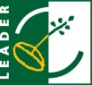 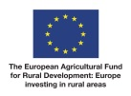 **** ****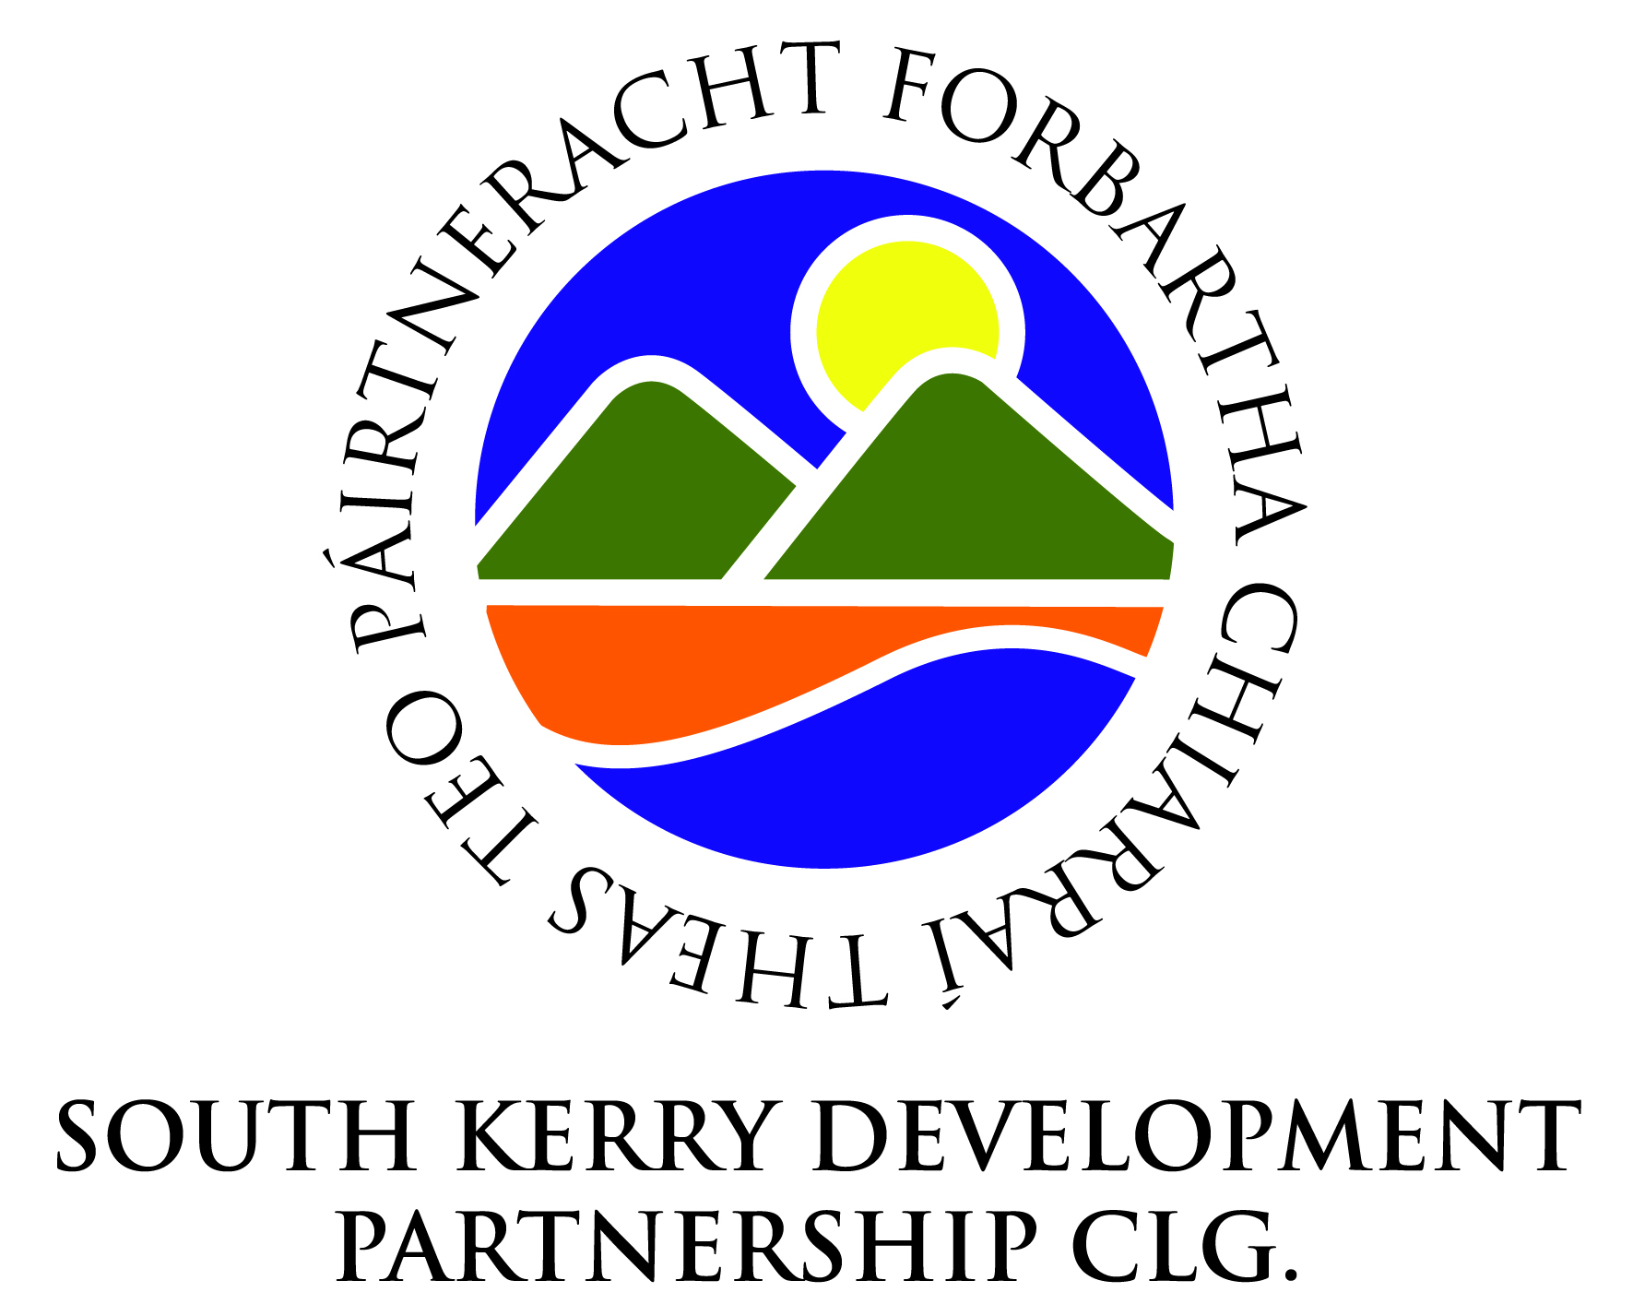

**Funded by the Department of Rural & Community Development**