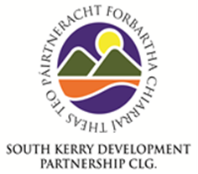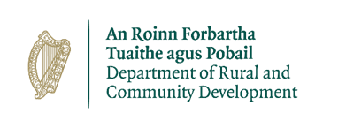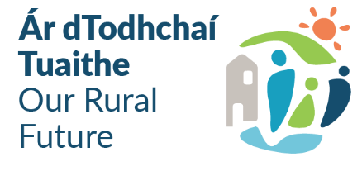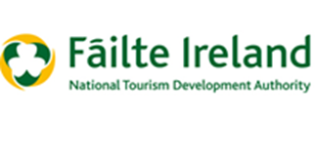
SKDP – Expression of Interest Form
Outdoor Recreation Infrastructure Scheme 2022
Measure 1: Small-scale Repair/Development/Promotional and Marketing Projects
Applicant Details
Community Group
Contact Person
Phone
Email
Project Proposal
Outline of proposed project
Has funding for this project been sought from any other sources? If yes, please specify what source and up to date position regarding those applications
Is there a clear need in the local area for a project of this type and does it deliver a positive impact for the local area from either a tourism/health or economic perspective?
Outline how the project will support an inclusive approach or enhance opportunities for people with disabilities
Are all permissions (planning etc.) and/or approvals required in order to complete the project in place? If not please provide details regarding the current position:
Project Costings
Total Estimated Project Cost
Community Contribution

Please provide breakdown of project timelines including anticipated start date/completion date

 | Indicative Date: | Brief description of work to be completed:
Start Date:
Completion Date:
Please forward completed Expression of Interests by email to Clyne@skdp.net or by post to: Concubhair Lyne, RRO, SKDP, West Main Street, Cahersiveen, Co. Kerry
Closing date for receipt of Expression of Interests is 31st March 2022 @ 5pm

